ANZAC

Te Hokowhitu a Tū-Te 28/The Māori Battalion

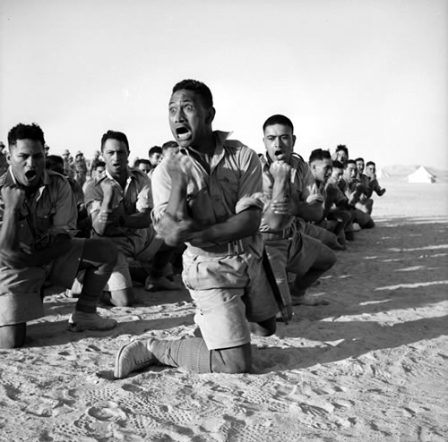

TE REO AUAHA
Te Hokowhitu a Tū-Te 28/The Māori Battalion
E whai ake nei ko wētahi kōrero e pā ana ki wō tātau koroua, i wō tātau matua kēkē hoki. Rātau, i haere ki te mura o te ahi i te Pakanga Tuarua. Wētahi i oti atu, wētahi i hoki mai.

Hei Mahi 1

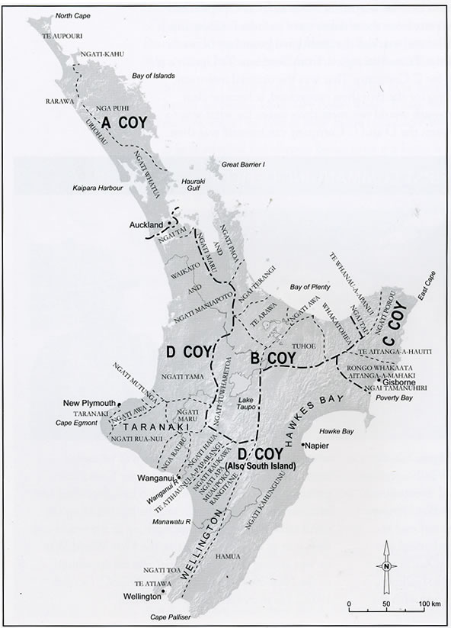
E whā ngā wehenga o te Hokowhitu ā Tū (The Māori Battalion) I wehea ā rohe, ā iwi. Mau tonu tēnā rohe i ngā mana motuhake o tō rātau ake rohe. Tirohia te mahere kia āta mārama ai koe ki ngā wehenga

A Company:
Ngāpuhi, Ngāti Whātua me ētahi atu o ngā iwi o te raki o Aotearoa. Ko te ingoa tohu ko Ngā Keri Kapia, he pānga ki te keri kāpia mai i ngā rākau kauri.

B Company:
Te Arawa, Mataatua, Ko te ingoa tohu ko Ngā Ruku Kapa, e pā ana ki te mahi ruku kapa te hunga o Te Arawa.

C Company:
Te rohe o Te Tairāwhiti. Ko te ingoa tohu ko Ngā Kaupoi. Nā te mea he iwi tino kaingākau ki te eke hōiho.

D Company:
Te Waipounamu me ngā toenga o Te Ika a Māui, arā, a Waikato, Taranaki, Manawatū me te Wairarapa.

Headquarters (HQ) Company:
Ko ngā ringa whakahaere i ahu mai i ngā tōpito katoa o te ao Māori.

Hei Mahi 2 He Mahi Pānui
E whai ake nei ngā whakamārama mō ngā pakanga i pā ki te Hokowhitu ā-Tū, arā te Hokowhitu-28. Ko tāhau he pānui i ia pakanga kātahi, ka whakaraupapa haere. Ko te tau o te pakanga me te wāhi e tuhi i te rārangi ā-wā.

Nō te 1940 ka wehe atu ngā tama toa o Aotearoa mai i Te Whanganui ā Tara i runga i te Aquitania. Ko te kaupapa ko te pakanga tuarua. Koia nei te pakanga ki a Tiamana. Ko te ingoa o te rōpū taua Māori ko Te Hokowhitu 28. He haerenga nui, he haerenga toa, he haerenga oti atu ki ētahi o ngā tama toa nei.
‘Haere atu rā ngā tama a Tūmatauenga ki te kawe i te mana tangata, mana kāinga, mana whenua e-e-e’
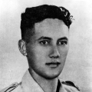
2nd Lieutenant Ngārimu, VC
Tū māro, tū māia, tū ngātahi ana te 28 me ngā ope taua ki te ārai atu i te whakaeke a ngā Tiamana i Medenine, Tunisia. Ko te whainga a te Ope Taua o Aotearoa kia eke rātau ki Tebaga Gap, ki te pupuri i taua āpiti. Ū tonu, mau tonu a Tebaga Gap i te tau 1943. Takoto ana te tangata i tēnei o ngā pakanga. Ko tētahi ko Te Moananui-a-Kiwa Ngārimu i whakawhiwhia ki te tohu toa, arā, te Victoria Cross. Kātahi hoki ētahi mātātoa ko ēnei.

Ahakoa te paku noa o te tauranga tereina o El Alamein he parekura nui anō i konei i te tau 1942. Ko te kāpene o ngā hoariri i tū mai ko Rommel, tētahi niwha o te niwha. Kore rawa ngā toa a Tūmatauenga e hoki whakamuri. Ko Rommel tēnā me tana ope taua te oma ana. I konei ka puta te whakataukī a Rommel, ‘hōmai tētahi ngohi Māori, ā, ka riro te ao i au’.

Nō te tau 1943 ka kake te tokoiti i te pari poupou rawa atu. Ko te whāinga kia eke ki te tihi o Takrouna. Rere ana te toto, marū ana ngā tinana, hingahinga ana ngā toa. Engari, nō te mutunga ko te hoariri kai raro, ko ngā toa a Tūmatauenga kai runga.

Ko te mura o te ahi tēnei i te rohe o te Mediterranean, te kāinga o ngā Atua Kirihi, arā i Greece. Ahakoa te tū atu a te ope taua kore rawa te hoariri i hinga. Koia rā tētahi parekura nui i pā ki te Hokowhitu 28. Nō te tau 1941 tēnei pakanga. Tū atu tū mai, tū mai tū atu te rere o te whawhai. Ahakoa tēnei parekura nui ki ngā ope taua (te Taua Tuarima) otirā, ki te ope taua rawa atu o Aotearoa. Kitea ana te niwha, te māia, te toa o te Hokowhitu a Tū ki te whawhai kanohi ki te kanohi. I konei ka puta te rongo o te Te Hokowhitu 28.

I heke kē mai te hoariri mai i ngā rangi. Koia nei te hekenga tuatahi pēnei rawa atu He hekenga whakaniwha rawa ki te papa rererangi o Maleme, i te motu o Crete i te tau 1941. Me pēhea hoki e ngā ope taua ngātahi te tū atu. Heoi noa, ko te mamau, ko te mau noa i ā rātau pēneti me ā rātau pū. Me pēhea te kakari atu ki te tini me te mano hoariri. Karawhiua ana ngā Ope Taua Ngātahi, karawhiua ana te Hokowhitu 28.

Ka tukuna te ope tū taua o Aotearoa ki Syria i te tīmatanga o te tau 1942. Ko tā rātau he aukati i ngā Tiamana ka whakauru mai i te taha tonga o Iuropa, arā, mai i te whenua o Russia, o Turkey hoki. Koia rā tā ngā kaiwhakahaere i kī ai engari, auware ake te hoariri i whakaeke. Nō reira, he wā tēnei mō te Hokowhitu ā Tū ki te whakaharatau, ki te hanga huarahi, ki te whakatū pā hei pare atu i te hoariri.

Auē, auē kua tau, kua tau. Nō te 1946 ka whakatauhia ngā tama toa a Tūmatauenga i te Whanganui ā-Tara. I kōnei ka kī a Colonel James Hēnare ki ngā mōrehu o te 28,

‘Hokia, ki ō tātau maunga, ki ō tātau whānau, ki ō tātau marae. Koia nei tāku ki ā tātau, tū Māori ake ake ake.’

Ko te mutunga atu o te 28, otirā o te Hokowhitu Tuarima ko te taone o Trieste i te tau 1945. I konei tā rātau tū ngātahi atu ki te kino, ki te wehi, ki te whakaweti ki te whakawhiu. Heoi, e whitu marama rā anō i muri i tēnei pakanga kātahi anō ngā mōrehu ka tau ki te wā kāinga.

He parekura nui anō tēnei ki te 28. I te 1944 ko te pakanga o Cassino. Kore rawa i hinga i ngā ope taua te hoariri. Tū ngātahi ana te hoariri i tēnei o ngā pakanga. Inā, ko rātau kē i hoki whakamuri i mua i tō rātau matenga i te hoariri. Ko tētahi karawhiu nui ko te tāorohia o te whare karakia Benedictine. Moumou rawa atu. Nā te whakahau a tētahi o te ope taua ngātahi i kore atu ai tēnei whare tipuna me ōna kōrero whakaharahara.

Nō te tau anō o te 1941 ka hūnukutia te ope taua o Aotearoa ki Libya. Ko tā rātau he tautoko i te ope taua o Piritānia (te Taua Tuawaru) ki te pana haere i te hoariri e tāoro ana i Tobruk. Koia nei hoki te wā tuatahi i whawhai ai ngā taua nei i te mārakerake. Ko te kai a te Hokowhitu 28 i te mārakerake, ko te wera, ko te puehu, ko te kirikiri, ko te hau.

Kuputaka

āpiti gorge

aukati defend

auware incomplete

hoariri enemy

Hokowhitu 28 28th Māori Battalion

hūnuku despatched

Iuropa Europe

kakari struggle

karawhiu beating/loss

mamau hand combat

mārakerake desert

marū bruised/wounded

niwha fearsome/formidable

ope group/fighting body

Ope Taua Ngātahi Allied Forces

pā bulwark

pare ward off/defend

parekura massacre/bloodbath

pari cliff

pēneti bayonets

poupou steep

tāoro overthrow / vanquish

taua warrior

Taua Tuarima Fifth Division

te mura o te ahi the heart of battle / the frontline

whakaeke attack / offensive
whakaharatau training
whakaniwha terrifying

Hei Mahi 3: Ngā Āhuatanga Reo/Nuka Reo

He maha ngā āhuatanga reo/ nuka reo rānei kai roto i te reo Māori:
- ko te kīanga kīwaha, (colloquialism)
- kīanga whakataukī, (proverbialism)
- kīanga whakarite, (simile)
- kīanga whakapehapeha, (hyperbole)
- kīanga rongo ā-ngākau (emotional connection)
- kīanga huri hāngai (antimetabole) me wētahi atu.

Pānuihia ngā rerenga kōrero e whai ake nei. Tuhia ngā momo āhuatanga reo e hāngai ana. Kua mahia te mea tuatahi.

Tauira: Tētahi niwha o te niwha kīanga whakapehapeha-hyperbole, kīanga whakarite simile (El Alamein 1942). E whakarite ana i te tangata ki te taniwha, me te whakamōmona i tōna kaha.

Tirohia te Hei Mahi 2 ka tohu ai i ngā āhuatanga/nuka reo ka whakahāngai ai:
- Auē, auē, kua tau, kua tau. (1946 Te hokinga mai)
he kīanga _________________________________________________________________________________

- Rere ana te toto, marū ana ngā tinana, hingahinga ana ngā toa (1943 Takrouna)
he kīanga _________________________________________________________________________________

- ko te mamau, ko te mau noa i ā rātau pēneti me ā rātau pū, (Crete 1941)
he kīanga _________________________________________________________________________________

- tū ngātahi atu ki te kino, ki te wehi, ki te whakaweti ki te whakawhiu. (Trieste 1941)
he kīanga _________________________________________________________________________________

- “Hokia, ki ō tātau maunga, ki ō tātau whānau, ki ō tātau marae. Koia nei tāku ki ā tātau, E tū Māori ake, Māori ake, Māori ake.” (1946 Te hokinga mai)
he kīanga _________________________________________________________________________________

Hei Mahi 4

He mahi kupu tūingoa, rerenga tūāhua.

Pānuihia kia toru o ngā pakanga. Tuhia rawa ngā pakanga kua tautohua e koe, ka tīpako i ngā tūingoa me ngā rerenga tūāhua. Kua mahia te pakanga o Takrouna hai tauira 1943.

Te Pakanga o Takrouna 1943

Kupu Tūingoa Rerenga tūāhua
tokoiti Rere ana te toto, marū ana ngā tinana, hingahinga ana ngā toa
pari poupou rawa atu.
Takrouna he tihi
te hoariri kei raro e putu ana, ka takoto
Ngā toa a Tūmatauenga. ka takoto

Pānuihia ēnei pakanga hei whakatinana i te Hei Mahi 3

Ahakoa te paku noa o te tauranga tereina o El Alamein he parekura nui anō i konei i te tau 1942. Ko te kāpene o ngā hoariri i tū mai ko Rommel, tētahi niwha o te niwha. Kore rawa ngā toa a Tūmatauenga e hoki whakamuri. Ko Rommel tēnā me tana ope taua te oma ana.

Pānuihia ēnei pakanga hei whakatinana i te Hei Mahi 3

I heke kē mai te hoariri mai i ngā rangi. Koia nei te hekenga tuatahi pēnei rawa atu He hekenga whakaniwha rawa atu ki te papa rererangi o Maleme, i te motu o Crete i te tau 1941. Me pēhea hoki e ngā ope taua ngātahi te tū atu. Heoi noa, ko te mamau, ko te mau noa i ā rātau pēneti me ā rātau pū. Me pēhea te kakari atu ki te tini me te mano. Karawhiua ana ngā Ope Taua Ngātahi, karawhiua ana te Hokowhitu 28.

Pānuihia ēnei pakanga hei whakatinana i te Hei Mahi 3

Tū māro, tū māia, tū ngātahi ana te 28 me ngā ope taua ki te ārai atu i te whakaeke a ngā Tiamana i Medenine, Tunisia. Ko te whainga a te Ope Taua o Aotearoa kia eke rātau ki Tebaga Gap, kia pai ai tā rātau pupuri. Ū tonu, mau tonu a Tebaga Gap i te tau 1943. Takoto ana te tangata i tēnei o ngā pakanga. Ko tētahi ko Te Moananui-a-Kiwa Ngārimu i whakawhiwhia ki te tohu toa, arā, te Victoria Cross. Kātahi hoki ētahi mātātoa ko ēnei.

Pānuihia ēnei pakanga hei whakatinana i te Hei Mahi 3

Ko te mura o te ahi tēnei i te rohe o te Mediterranean, te kāinga o ngā Atua Kiriki, arā i Kirihi. Ahakoa te tū atu, a te ope taua kore rawa te hoariri i hinga. Koia rā tētahi parekura nui i pā ki te Hokowhitu 28. Nō te tau 1941 tēnei pakanga. Tū atu tū mai te rere o te whawhai. Ahakoa tēnei parekura nui ki ngā ope taua tū ngātahi otirā, ki te ope taua rawa atu o Aotearoa (te Taua Tuarima) kitea ana te niwha, te māia, te toa o te Hokowhitu a Tū ki te whawhai kanohi ki te kanohi. I konei ka puta te rongo mō te Te Hokowhitu 28.

Hei Mahi 5 He Pānui

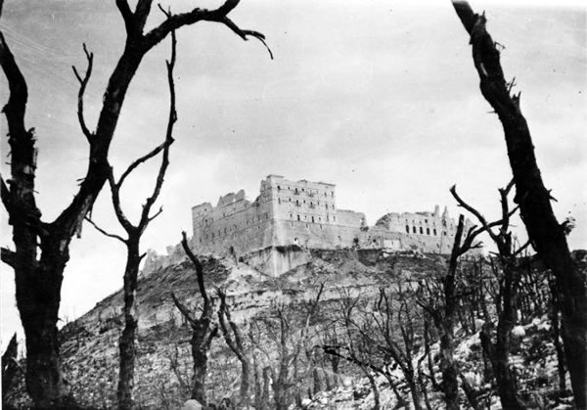

Monte Cassino
He maha ngā whānau i tapa, i ā rātau tamariki ki ngā ingoa mai i te pakanga tuarua, Ko ētahi ingoa hei whakamaumahara i tētahi pakanga, i tētahi wāhi, i tētahi hingana rānei. Koia nei tētahi o aua ingoa. I tonoa mai e tētahi o ngā hōia o te 28 te kōrero mō te pakanga mō Monte Cassino. I muri tonu i taua pakanga ka tae te kōrero ki te whānau kua hinga tā rātau tama. Ka tapaina e te whānau te pēpē i whānau i muri tata i taua pakanga ko Cassino, hei tohu i te uri i hinga rā i Cassino. Ināianei kua motuhake te ingoa Cassino hei ingoa whānau.

Kuputaka
tapa ko te whakaingoa
pakanga ko te whawhai mō tētahi wāhi
hinga ko te mate i te wā o te pakanga
tono ko te tuku i tētahi kōrero
Monte ko te kupu Itāriana mō te maunga
motuhake ko te mana, ko te mau pūmau
uri ko te whanaunga, te karawa, te whakapākanga

Hei Mahi 6: He Whakaari

Nō Hea Tērā Ingoa?

Te Horopaki
Kai te kōrero a Tamati, a Cassino, a Kāhira me Pōrua mō te mana o te ingoa.

Ngā Kiripuaki
Tāmati (11 ōna tau) Kāhira (Māmā)
Cassino (e 9 ōna tau) Pōrua (Kui)

- Tāmati: (reo whakatoi) Cassino Passino hai, hai, hai (kata)

- Cassino: (tioro) Kaua e tapa i au ko Cassino passino. Ehara koinā taku ingoa Tāmati pānati.

- Kāhira: Pai kare e kōrua. He aha koe e tioro nā Cassi?

- Cassino: (amuamu) He whakaiti nō Tāmati i taku ingoa.

- Tāmati: E kāo. Kai te whakanui kē au i tō ingoa Cassino passino (kata)

- Cassino: (pukuriri) Kāre au e pīrangi i tērā ingoa.

- Pōrua: (reo whakatau) Tēhea ingoa moko?

- Cassino: (āki) Cassino! Nō hea nei tērā ingoa. He aha tōku ingoa i pākehā ai, ko wō koutou he māori katoa?

- Tāmati: Nā te mea he pākehā nōhou Cassino pāssino. (kata)

- Kāhira: E kī rā Tāmati whakaputa mōhio. Haramai ki konei noho ai Cassi kia rongo koe i te mana o te ingoa.

- Pōrua: (kata) Tika tāu mokopuna. Nō mātau te hē. He kore e kōrero mō ngā ingoa o te whānau. Pēnā i tōhou ingoa nā Tāmati. Nō hea mai tō ingoa?

- Tāmati: (reo whakahī) Nō Koro. He ingoa mai i te paipera tapu. He tangata hī ika a Tāmati, pērā anō hoki a Koro.

- Kāhira: Engari ko koe Tāmati, he kai ika noa iho te mahi ka pahawa.
- Cassino: Tika! (kata)

- Tāmati: Yummi, me te rawe hoki ki ahau Māmā. (kata) Ngā kanohi rawa nē rā Cassino pa ...

- Cassino: Hai aha tāu Tāmati Pānati.

- Pōrua: (kata) Mōhio koe nō hea mai tō ingoa e moko?

- Tāmati: (kata) Nō te pouaka witipiki?

- Kāhira: (āki) Turituri!

- Pōrua: E kāo e moko, nō te whenua o ngā Ariki. Āe, nō Itari rā anō.

- Cassino: (mīharo) Nē e Kui?

- Pōrua: Āe e Moko, Ehara i te ingoa pākehā. Engari he ingoa Itāriana kē. Ko te roanga o tō ingoa ko Monte Cassino.

- Tāmati: Ei, He aha hoki te Monte?

- Pōrua: He maunga tērā. I tapaina tērā ingoa a Cassino ki taku tuakana. Hei whakamaumahara i te pakanga i Itari. Kite kōrua i te whakaahua o Koro Hēmi e iri rā i te rūma nohonoho. Āna, i mate tō kōrua koroua i te pakanga mō Monte Cassino.

- Tāmati: Aaa, āna ko te Cassino he maunga nē Kui?

- Kāhira: (kata) Ka pai Tāmati. He roro tonu kei waenganui i ō taringa.

- Cassino: Wii, nē kui? Hei whakamaumahara i a Koro nē. Hmm ... Māmā, kāti te karanga i au ko Cassi, me karanga i taku ingoa motuhake, Cassino.

- Tāmati: Wou tuahine, he tipuna maunga kē tō ingoa. Haramai, ka haere tāua ki te kōrero ki a Puni. Wou, he tipuna, he maunga, Cassino.

Hei Mahi 7: Tīpakohia te whakautu hāngai tonu.

- He aha a Cassino i kore ai i hiahia ki tōna ingoa?
a) Nā te mea ehara i te ingoa Māori.
e) Kei te hiahia ingoa pākeha kē ia.
i) Nā te kaha o Tāmati ki te tautoko i a ia.

- He pēhea nei te wairua o Tāmati?
a) He tama kaha ki te whakatoi ki tana tuakana.
e) He tama kaha ki te whakatoi.
i) He tama kaha ki te whakatoi ki tōna pāpā.

- Nō hea mai te ingoa o Cassino?
a) Nō Aotearoa.
e) Nō Koro Hēmi.
i) Nō Itaria.

- He aha nei te tino kaupapa o te ingoa o Cassino?
a) Hei whakanui i tētahi maunga.
e) Hei whakamaumahara i te pakanga i mate ai tōna koroua.
i) Hei whakapai i tōna āhua.

- Whakamāramahia mai nō hea tōhou ingoa. He aha te tino kaupapa o tōhou ingoa?

Hei Mahi 8: He mahi kupu

Tirohia ngā kupu e whai ake nei ka tohu i te whakamārama e hāngai ana. Kai ngā kōrero hoki o Monte Cassino ētahi whakamārama.

tapa (3) ko te mau tonu o ngā whakaaro ki tētahi tangata
turituri (20) koirā noa iho te mahi ka taea
pakanga (25) ko te kupu Itāriana mo te maunga
motuhake (28) ko te kati i te waha
pahawa (14) ko te whakatoi
whakamaumahara (25) ko te mau tūturu ki tētahi kaupapa, ingoa rānei.
Monte (23) ko te whakaingoa
iri (25) he whawhai
whakaiti (5) ko te tautau i te pātū

Hei Mahi 9: He tuhi whakaari (Mahi takirua)

Kai te tautohe ngā mātua mō te ingoa o tā rāua pēpē. Kāre anō te pēpē kia whānau mai. Ko pāpā kai te hiahia ki te tapa i te ingoa o tētahi tangata kiriwhakaari, pērā i a Cliff, Matt, Leo rānei. Ko Māmā kore rawa i te whakaae ki tēnei āhuatanga o te tapa ingoa, ko tāna kia ingoa Māori, otirā kia mōhiotia te whakapapa o taua ingoa. Kia eke ki te 15 ngā tautohetohe. Me uru te wairua katakata, whakatoi, pukuriri hoki.

ANZAC Resource
E te Hokowhitu –a-Tū
Composed by Tuini Moetu Haangu Ngawai

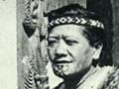

He Waiata

Requirements
- Words to waiata

Explanation
Tuini Moetu Haangu Ngawai (5 May 1910 - 12 August 1965)
was a well-known Māori songwriter. She was born at Tokamaru
Bay. Her iwi is Ngāti Porou and her hapū is Te Whānau a
Ruataupare. When her twin sister died at a young age,
Moetu was given the name Tuini, a transliteration of twin.
Tuini Ngawai composed many songs using European tunes,
to encourage Māori pride and to raise morale among Māori
at home and at war. Waiata, such as Hoki mai e tama mā and
E te Hokowhiti-a-Tū (to the tune of In the Mood) are still sung widely today.

References and Further Resources
Words for E te Hokowhitu-a-Tū are from Kia Mau at TKI, see http://eng.kiamau.tki.org.nz/Multimedia/Company-C/Rendition-of-the-waiata-E-te-Hokowhitu-a-Tu.

DVD explaining the meaning of E te Hokowhitu-a-Tū, see http://eng.kiamau.tki.org.nz/Multimedia/Company-C/The-meaning-of-te-waiata-E-Te-Hokowhitu-a-Tu

Biography of Tuini Ngawai, see Te Ara (The Encyclopedia of NZ) http://www.teara.govt.nz/en/biographies/5n11/1

Tuini Ngawai and Te Hokowhitu-a-Tū concert group, see http://eng.kiamau.tki.org.nz/Multimedia/Company-C/Tuini-Ngawai-and-Te-Hokowhitu-a-Tu-concert-group.

E Te Hokowhitu-a-Tū

E te Hokowhitu-a-Tū kia kaha rā
Kāti rā te hingahinga ki raro rā
Mā ngā whakaaro kei runga rawa rā
Hei ārahi i te ara e tika ai
Whirinaki, whirinaki tātou katoa
Kia kotahi rā (x2)
Ngā marae e tū noa nei
Ngā maunga e tū noa nei
Auē rā e tama mā
Te mamae te pōuri nui
E patu nei i ahau inā
Ngārimu auē
Anei ō hoa e
E rurutu nei
E te ope tuatahi
o te rōpū Māori e
Haere mai ki te hui o Ngārimu e (x2)
I te wā o te oranga
Kei te piri tahi e
I te matenga ka mokemoke e
Ka ara mai nei i tuinihia
Ka ara mai nei i tuinihia
Ko te tohu nui ko te wikitōria
Kei te whiti pāmamao tō tinana e tama
Ko te wairua kei runga Aotearoa (x2)

Sources for the information about Tuini Ngawai are from Te Ara http://www.teara.govt.nz/en/biographies/5n11/1, and Wikipedia http://en.wikipedia.org/wiki/Tuini_Ngawai.

