Te Rourou Reo  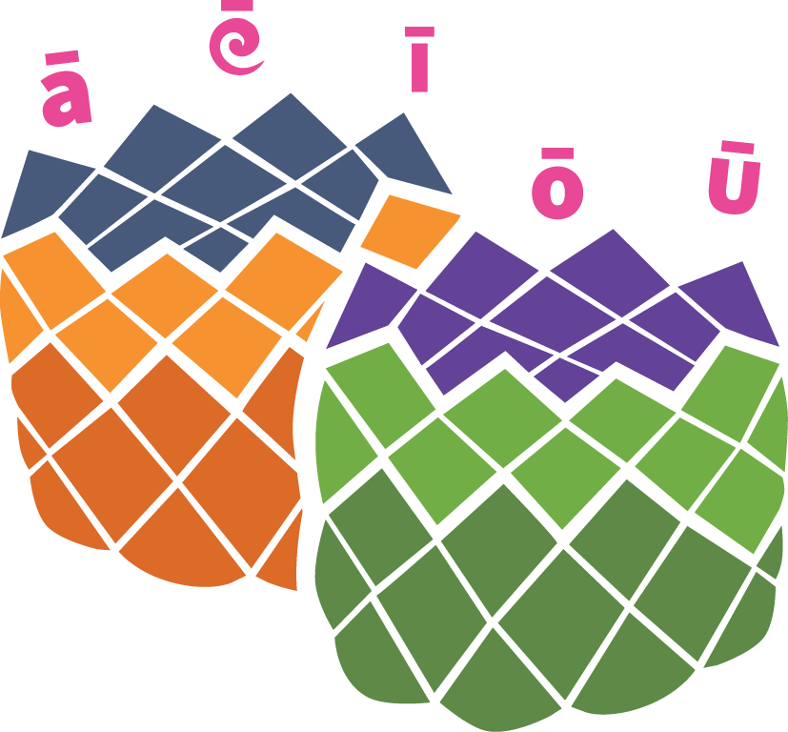 | Rapu Taonga  Look for things inside and outside the house that begin with: K, R and P. (E.G. K - kapu).  Whakaari  Act out a favourite part from a movie you have watched OR have a lip sync competition and lip sync a favourite waiata.  Whakapapa  Search through whānau photos and create a ‘whakapapa’ tree with them. Ko wai a wai? Name each whānau member and their position in the whānau.  Kōrerorero  Ring and kōrero with a whānau member every day. Maybe try video chatting with them.  Te Arapū  List the letters in the Māori arapū (alphabet). Next to each letter, write the name of a whānau member whose name starts with that letter. For other letters, write the name of a kai, a manu, or something that starts with that letter.  Whānau i te Whare  Who are the people in your whare? What are their pukenga? Make a list of each person and write a paragraph or find a kīwaha/whakataukī that describes them.

Te Tunu Kai | Chocolate Crunch  Scrambled Eggs  Scones  Easy, Tasty Snack
Te Toi Ako | Paper Planes  Make a Paper Plane. Decorate it with your favourite colours or recycled materials. If you need instructions, click here.  Pōtae Pōrangi!  Have a hat competition with whānau. Recycle materials you find at home to decorate or make a special hat. Set up a ‘cat walk’ and get everyone to model their hats. Let’s see who wins!  Rau Ngahuru  Collect leaves from outside. Create leaf rubbing pictures with crayons or coloured pencils.  Hangarua  Using recycled materials from around the whare, design and create a wind chime. Use string, shells, beads … anything you can find! Here are some instructions for making a wind chime from recycled tin cans.  Mahi Auaha  Te Whakarākei Ipu Hangarua (Siobahn Houkamau)  Tīpare  Design and make your own tīpare (headband). Recycle paper or paper bags and decorate or create a pattern and colour it in. Take a selfie and share with the whānau or your classmates.
Whakapakari i te Whare | Tik Tok  Learn a Tik Tok kanikani. Start a whānau Tik Tok wero. (You’ll need to ask an adult to download the app).  Easy Circuit  Create an easy exercise circuit. Start with 3 different exercises and work up to 6 over the coming weeks. Some example exercises are, star jumps, running on the spot, skipping, sit ups, press ups.  Kimi Taonga  Hide objects around the whare. Get others to walk around and try to find them. Don’t make it too easy - put some outside, behind bushes, up a tree.  Whakapakari Tinana  For more of a challenge, follow one of the ‘Fitness in the Whare’ episodes from Māori TV.  Whakatika Moenga  Make your bed each morning and clean your room.  Horoi Waka  Get outside with a bucket of soapy water and clean the car. Don’t forget to clean the rims of the tyres! Clean the inside with the vacuum.  Ngaki Māra  It takes a lot of energy and strength to weed the garden. Set aside time to weed a part of the garden and sow some vegetables. If you don’t have seeds, save some of your left-over, raw vegetables like lettuce, onions, garlic and grow in a small glass of water. Watch them sprout. When they are ready, plant in the garden.
Te Puna Pāngarau  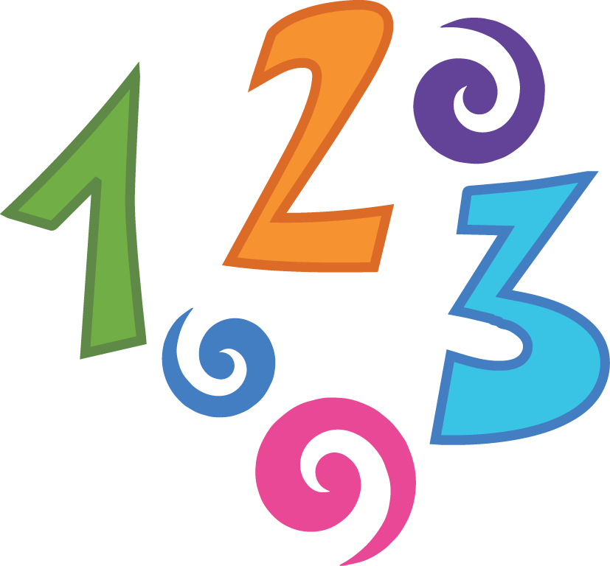 | Simon Says “Geometry!”  Use your arms to make the shapes when Simon tells you to e.g. porohita/circle; tapatoru/triangle; rārangi/a straight line. If you need to, join with someone else to make your shape.  Round the World  Stand in a circle with a ball (or some other item) and decide on a pāngarau problem that requires a response e.g. counting in 2’s, 5’s, 10’s or adding on 5 from the original number e.g. 1 + 5, the response will be 6. When each person receives the ball they have to say the next number.  Number Mat  Draw a grid on a big piece of material or paper (3x3). Write some simple addition or multiplication equations in each box. Use a stone or small bean bag to throw onto the grid. Whichever box you land on is the equation you must answer.  Cards  Using everyday playing cards, deal 5 cards to each player. Each player lays 2 cards down, then subtracts the lower number from the higher, or adds the two cards together. (Ace = 1, Jack = 11, Queen = 12, King =13).  Kēmu Pāngarau  Here are some more easy games to use when practising maths with your tamariki.  Meka Matua  Learn your times tables.
Tāia, Tuhia, Tākina | Whakaaro Huritao  Spend 5 minutes each day writing down your thoughts and reflections, or draw an emoji to describe how you are feeling. Include one thing you are grateful for, or something you really enjoyed doing that day.  Create a timetable  Each day, outline what you will do with your day. Don’t forget to add the times and how long you will do each activity.  Karakia  Create a karakia to protect your whānau. Tākina te karakia with whānau in the morning and at night. Keep it simple.  Te Taiao  Spend time noticing your taiao! How many different leaves can you see? How many different rākau? How many manu? Make a list, take a photo, draw a picture, scrapbook.  Just imagine!  Who isn’t in your whare but you would like in your whare? Why would you have them in your whare? Write a few sentences to explain why you would like them to be in your whare. Draw a picture to go with your writing.  Be Kind  What are the things you appreciate that you cannot do at the moment? What is one act of kindness you could do for someone in your whare today? What is one act of kindness you could do for yourself today? Make a poster/ wordle / list of different acts of kindness.
He Rau Hanganga | Ngārara  Go for a walk outside. Can you find some ngārara like pungawerewere, ngata, pūrerehua. How many can you find? Draw a sketch and label some parts of their tinana e.g. parirau - wings.  Gloop  Make some Gloop: Gloop Recipe  Mirumiru  Build your own bubble wand using a plastic bottle or a cup Bubble wands. Now make some bubbles using soap or dishwashing liquid. Ask an adult first.  Ngārara Blaster  Design and build a ‘Master Virus Blaster!’ that will cure the Coronavirus. Use items from around the house like glad wrap rolls, newspaper, magazines, bottles or tins.  Kanohi Ārai  Create your own face mask/ārai kanohi using material, paper bags. Decorate it and make it cool!  Tāwharau  Build a hut either inside or outside. You can use blankets, cushions and chairs if you are inside. Find a book, lie down and read.

